VLN MEETS THE FLUOR ENGINEERING CHALLENGE 2016

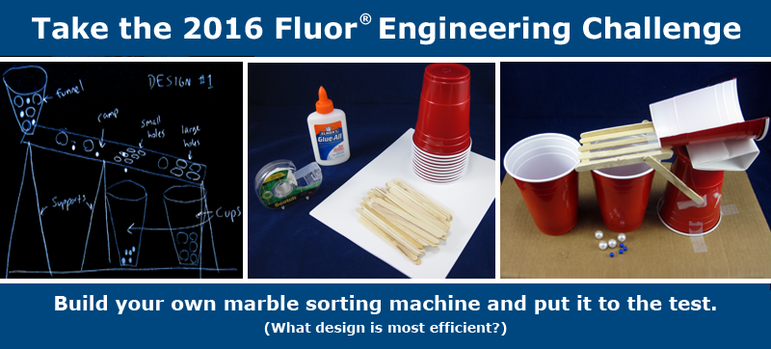

IF WE WIN, WE WILL HAVE A CELEBRATION FOR ALL PARTICIPANTS HERE AT THE SCHOOL.
WHO: Any VLN student in Grade 3 to Grade 12 (that’s you )

WHAT: Make a marble-sorting machine*; VLN will provide the basic materials. You may bring tools like rulers or scissors.
(*Complete details are here.)

WHERE: Room 117 at the VLN
(East Wing of John Oliver Secondary School, 530 E. 41st Avenue, Vancouver; enter at the back of the school, near the brown portable)

WHEN: Tuesday, February 23rd from 9:30 AM to 12:00 PM
Use the VLN Field Trip Form to get permission to participate. We would also appreciate it if you could bring a completed VLN Media Release Form.

WHY: Meet teachers! Meet other students! Fun! Snacks! More!

CLICK HERE TO SIGN UP: DEADLINE WEDNESDAY, FEBRUARY 17

ANY QUESTIONS? CONTACT MS. HORNG BY E-MAIL: shorng@vsb.bc.ca

Here is an HTML code for a News Item that will look very much like the above:

<p style="text-align: center;"><span style="color: #085394; font-size: 14pt; font-family: verdana, sans-serif;"><strong>VLN MEETS THE FLUOR ENGINEERING CHALLENGE</strong></span></p>
<p><span>&nbsp;<img src="/content/Miscellaneous/SHorngSandbox/FINALfluor-challenge-2016-landing.png" alt="" title="" style="display: block; margin-left: auto; margin-right: auto;" width="436" height="197" /></span></p>
<p></p>
<p style="text-align: center;"><strong><span style="color: #cc0000;">IF WE WIN, WE WILL HAVE A CELEBRATION FOR ALL PARTICIPANTS HERE AT THE SCHOOL.</span></strong></p>
<p><strong><span style="color: #cc0000;"><span style="font-size: 18pt;"><span style="color: #085394;"><span style="font-size: 14pt;">WHO:</span> <span style="font-size: 12pt; color: #6fa8dc;">Any VLN student in Grade 3 to Grade 12&nbsp;(that&rsquo;s you &nbsp;<img src="/content/Miscellaneous/SHorngSandbox/thumbs%20up%20yellow%20smiley.jpg" alt="" title="" width="45" height="38" />&nbsp;&nbsp;)</span></span><span style="font-size: 14pt;"></span></span></span></strong></p>
<p><strong><span style="font-size: 18pt; color: #2b78e4;"><span style="font-size: 14pt; color: #085394;">WHAT: </span><span style="color: #6fa8dc; font-size: 12pt;">Make a marble-sorting machine*; VLN will provide the basic materials. You may bring tools like rulers or scissors.&nbsp;</span></span></strong><strong><span style="font-size: 18pt; color: #2b78e4;"><span style="color: #6fa8dc; font-size: 12pt;"><span style="font-size: 8pt;">(*Complete details are <a href="http://www.sciencebuddies.org/fluor-challenge" target="_self">here</a>.)</span></span></span></strong></p>
<p><strong><span style="color: #085394; font-size: 14pt;">WHERE:</span><span style="font-size: 12pt; color: #6fa8dc;">Room 117 at the VLN</span></strong></p>
<p><strong><span style="font-size: 12pt; color: #6fa8dc;"><span style="font-size: 8pt;">(East Wing of John Oliver Secondary School, 530 E. 41st Avenue, Vancouver, enter at the back of the school, near the brown portable)</span></span></strong></p>
<p><strong><span style="font-size: 18pt; color: #2b78e4;"><span style="font-size: 14pt; color: #085394;">WHEN:</span> <span style="font-size: 12pt; color: #6fa8dc;">Tuesday, February 23<sup>rd</sup> from 9:30 AM to 12:00 PM&nbsp;</span></span></strong></p>
<p><strong><span style="font-family: tahoma, sans-serif; font-size: 8pt; color: #6fa8dc;">Use the <a href="https://docs.google.com/document/d/1HNmjMY79rgWCyVFLBNDWMB-XpVs_lchZrMDTTDJy3wY/pub" target="_self">VLN Field Trip Form</a>&nbsp;to get permission to participate. We would also appreciate it if you could bring a completed <a href="https://docs.google.com/document/d/1KxZu-L3IiIpmEDrdlmzhF5WBzdsAAJmoZGPQPxwgtC0/pub" target="_self">VLN Media Release Form</a>.</span></strong></p>
<p><strong><span style="font-size: 18pt; color: #2b78e4;"><span style="font-size: 14pt; font-family: tahoma, sans-serif; color: #085394;">WHY: </span><span style="color: #6fa8dc; font-size: 12pt;">Meet teac<span style="font-family: tahoma, sans-serif;">hers! Meet other students! Fun! Snacks! More!</span></span></span></strong></p>
<p><span style="color: #085394;"><span style="font-family: tahoma, sans-serif;"><strong><span style="font-size: 14pt;"><span style="font-family: tahoma, sans-serif;">CLICK <span style="color: #9900ff;"><a href="https://docs.google.com/forms/d/1gkQoPgkpldzh-60SKPhmun7OfG8_jBxbP_gj06bPOjQ/viewform" target="_self"><span style="color: #9900ff;">HERE</span></a></span>&nbsp;TO SIGN UP</span>: DEADLINE WEDNESDAY, FEBRUARY 17</span></strong></span></span></p>
<p><span style="font-size: 14pt; color: #2b78e4;"><strong><span style="font-family: tahoma, sans-serif;">ANY QUESTIONS? CONTACT MS. HORNG BY E-MAIL:</span></strong></span> <a href="mailto:shorng@vsb.bc.ca" target="_self">shorng@vsb.bc.ca</a></p>
<p></p>

